2019 Transit Input Validation Report

As part of the Mode Choice Update project, UTA, WFRC and MAG reviewed the 2019 transit inputs to the Wasatch Front travel demand model, version ‘8.3.1 - 2020-08-17’. Transit inputs include route and fare information, as well as operational characteristics. Where issues were found with the input data sets, the inputs were updated to correct for errors or to align with current transit operations. While all these inputs were reviewed, only the following needed updating:

* Hand-coded walk access links
* Light-rail transit speeds
* Park-and-ride lots
* Transit line files
* Walk buffer

Following the discussion of the updates, there is an analysis of the transit ridership validation for 2015 and before/after the 2019 updates, which considers trips and boardings by mode across the entire system. The final section contains a before/after comparison of boardings by service district and route.

It is expected that these updates will be applied in the next version of the Wasatch Front travel model. If a current project would like to use the updated transit input files, the project would most likely need to recalibrate the mode choice model to tune the model to the new inputs.

# Hand-Coded Walk-Access Links

Hand-coded walk-access links are an additional input for transit beyond the automatically generated walk-access links. Auto-generated walk-access links are created between zone centroids and transit stops within a certain distance as defined by area of the zone, as long as they do not cross barriers as defined by functional type. Hand-coded walk-access links are user-defined, supplemental walk access where an auto-generated link would not be created or where walk access is more attractive than the TAZ structure and auto-generated links would suggest.

The update process removed a majority of the general hand-coded walk access links, reducing the number from 234 to 31 links. Areas that retained or added hand-coded links include SLC International Airport, Hill Air Force Base, University of Utah, and Utah Valley University. Figure 1 shows hand-coded walk-access links before and after the updates.

|  |  |
| --- | --- |
|  |  |
| Before Updates | After Updates |
| Figure 1. Hand-Coded Walk Access Links | |

# Light Rail Transit Speed

The speed of rail transit is coded onto rail-only links within the master highway network. Transit speed for LRT were updated to reflect 2019 operations. Most of the speed changes were less than 5 mph. The map below shows where light rail speeds were changed.

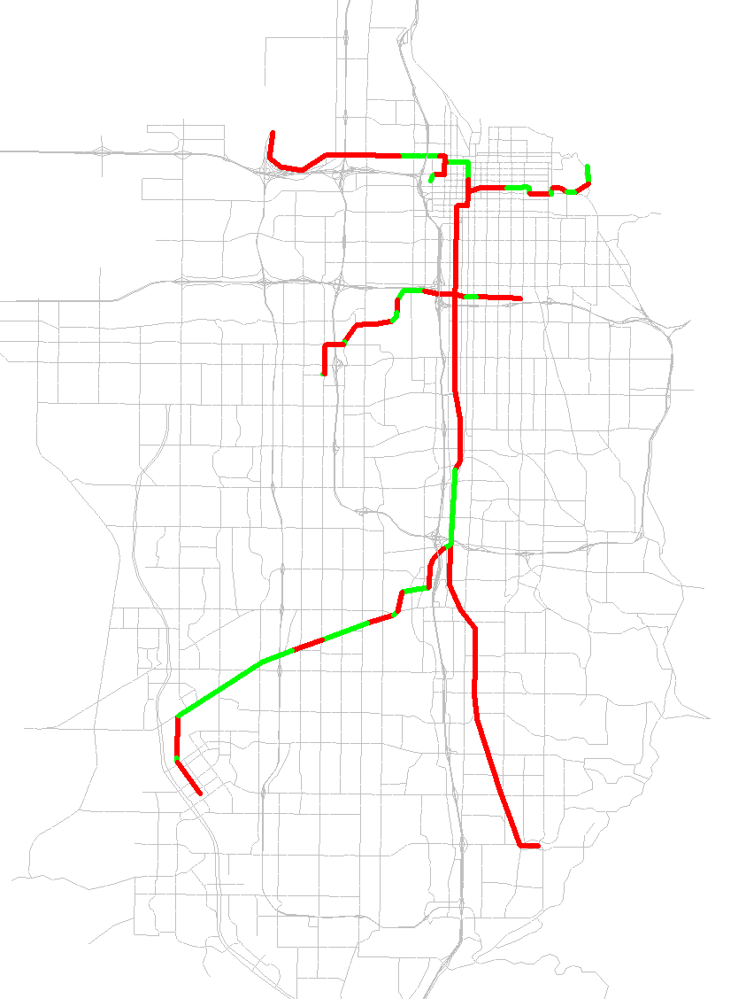

Green: Increase in Speeds — Red: Decrease in Speeds

Figure 2. Change in Transit Speeds for LRT in Salt Lake County

Table 1 Table 1. Average Travel Speed (MPH) by Route for LRTshows the resulting average speeds along entire light rail routes. The net effect of the update was generally lower speeds, with the TRAX-Blue line and the S-Line having the largest drops in speed with a drop of 8.2% and 14.5%, respectively.

Table 1. Average Travel Speed (MPH) by Route for LRT

| **Route** | **Before Updates** | **After Updates** | **Difference** | **% Difference** |
| --- | --- | --- | --- | --- |
| **TRAX-Blue** | 24.4 | 22.4 | -2.0 | -8.2% |
| **TRAX-Green** | 19.2 | 18.6 | -0.6 | -3.1% |
| **TRAX-Red** | 24.4 | 23.6 | -0.8 | -3.3% |
| **S-Line** | 13.8 | 11.8 | -2.0 | -14.5% |

# Park-And-Ride

Park-and-Ride lots are coded onto nodes within the master highway network and are defined by what transit mode they service. To be used by the travel model, park-and-ride nodes need to be coded at nodes that serve as rail or bus stops. Figure 3 shows what changes were made to park-and-ride lots, which include 17 additional locations, 49 removed locations, and 14 locations that were modified by changing the mode they service. Most of the park-and-ride lots removals were due to redundancy on highway nodes adjacent to another park-and-ride lot at a rail node. The park-and-ride lots additions mostly included new lots along express bus routes. The resulting park-and-ride lot locations, including ones that were not edited, are shown in Figure 4.

|  |  |
| --- | --- |
|  |  |
| Red: Removed — Green: Added — Blue: Modified  Figure 3. Park-And-Ride Lot Changes | Figure 4. Park-And-Ride Lots After Updates |

# Transit Line Changes

Transit line files were updated based on actual 2019 route configuration. Transit line files include route alignments, stop locations, and peak/off-peak headway designation.

A general edit that was made to all lines that connect directly to rail was the removal of bus stops on a roadway node directly adjacent to a stop at a rail node. Only the rail node stop remains. Due to the amount of lines affected by this change, they are not listed individually in the line details below.

There were also a couple of highway network edits made in relation to transit line changes:

* At the Blue Line end-of-line in Draper, the centroid connector for the rail station connection to the highway network moved off intersection of Pioneer Road / 1300 East intersection and connected directly to Pioneer Drive.
* A connection between 24th Street and Wall Avenue in Ogden was added to represent the existing connection on each side of the viaduct. The associated transit-only link was removed.

The line file changes are shown in the lists below, arranged by file and route name. Only lines that have changes, other than those listed above, are included.

**mag_brt_2019.lin**

* BRT_ProOrm:
  + Stops removed:
    - 24779 - Geneva Road
    - 26400 - 900 E/Campus Ln
    - 26487 - 750 S/100 W
  + Stops moved:
    - 22881 to 26206 (from intersection of University Pkwy/900 E to the west)
    - 25972 to 23019 (moved further west to intersection of 400 E/700 N)
    - 23069 to 26203 (moved further north off of intersection of 200 N/Univ Ave)
    - 23066 to 26202 (moved further south off of intersection of 300 S/Univ Ave)
    - 26184 to 26192 (moved off University Ave and onto Town Centre Blvd)
    - 23160 to 24332 (moved west of intersection East Bay Blvd/1860 S)
  + Alignment changed: Off of University Avenue between 920 S and Town Centre Drive and onto Town Centre Blvd

**mag_exp_2019.lin**

* M807_NoCnty: Many stops removed. Realignment changed at each end of route. Reverse direction removed.
* M806_EglMtn: Headway changed from 30/0 to 45/0. Many stops removed. Realignment changed at Eagle Mtn end-of-line and to stay on freeway through American Fork. Reverse direction removed.

**mag_lcl_2019.lin**

* M805_Santaquin: Headway 1/2 changed from 30/0 to 45/60. Stop added: 23552 (Santaquin end of line moved one node to west). Three stops removed in SF, only 25321 remains. Three stops removed in Provo: 26487, 26488, 23152.
* M809_AM-PG: Changed from two-way route to one-way route. Stops removed: 24769, 22358, 24162, 25729, 22389, 25727, 25513, 22514, 22390, 25726, 22392, 22394. Stops added: 24189, 22395.
* M821_Psn: Various stops removed.
* M822_Psn: Various stops removed.
* M831_WPr: Alignment changed around UVU. Various stops removed.
* M833_CntrPr: Various stops removals.
* M834_EstPr: Alignment changed at Univ Pkwy/2230 N. Various stops removed.
* M841_UVU: UVU main campus end-of-line moved one further node to 26601. Various stops removed.
* M850_StateStreet: Alignment Changed: Ashton Blvd & 2100 N, PG downtown, which required addition of reverse direction and change to one-way route due to one-way links. Various stops removals.
* M862_Orem: Alignment changed around UVU to use campus circulator roadway. Various stops removed.
* M864_Thanksgiving Point: Various stops removed.
* M871_SLtoUtahCnty: Northern end-of-line alignment changed to match updated highway network connection to Blue Line Draper Station.

**rail_2019.lin**

* OGPNShuttle: Route removed, since service to Pleasant View discontinued in 2015.

**wfrc_og_lcl_2019.lin**

* O601: Connection to Wall Avenue was removed from transit-only link and put on new highway network connection.
* O603: Southern end-of-line moved to McKay Dee Hospital.
* O606: Northern end-of-line moved from Harrison Blvd to Monroe Blvd.
* O608: Northern end-of-line moved from Harrison Blvd to Monroe Blvd.
* O628: Southern end-of-line extended to match southern circulation around Layton IHC.
* O630: Southern end-of-line moved from Weber State University to Ogden FrontRunner Station.
* O645: Northern end-of-line extended to US-89.
* OF618: Headway2 changed from 30 to 60.
* S470: Connection to Clearfield Station CRT added.
* S455: One stop removed in University of Utah area.

**wfrc_sl_exp_2019.lin**

* S2X: Changed to two-way route. Two stops removed on 200 South near Gateway. Two stops added in University of Utah area.
* S307X: Headway 1 changed from 30 to 47.
* S313X: Alignment through Fort Union area changed.
* S354X: Extended north end-of-line to Red Line station.
* S451X: Reverse direction removed.
* S454: Stop added at Green Line airport stop. Some stops along Green Line and North Temple moved to rail stop locations.
* S456: Stop added at Farmington Station CRT. Some stops along Green Line and North Temple moved to rail stop locations.
* S471: Alignment through Bountiful modified.
* S473X: Extended southern end-of-line further to Research Park.
* S902: Headway changed from 15/0 to 60/90. Some stops added.

**wfrc_sl_lcl_2019.lin**

* D461: Some stop in Woods Cross Station CRT area removed.
* S11: Eastern end-of-line shortened to stop at University of Utah Medical Center and not Red Line.
* S201: Southern end-of-line extended to SoJo Station CRT.
* S217: Alignment changed near green line (N Temple), route removed from 2200 West.
* S240: Alignment changed at Pieper Blvd.
* S41: West end-of-line extended one node down 5600 West.
* S463: Connection to Wood Cross Station CRT.
* S509: Alignment changed around SR-201.
* S526: Headway changed from 40/40 to 60/0.
* S551: Headway 1 changed from 30 to 40. Some stops along Green Line and North Temple moved to rail stop locations.
* SF453: Eastern EOL brought to rail node 20053.
* SF514: Stop added at SoJo Station CRT.
* SF546: Connection added to Draper Town Center Station CRT.
* SF94: Eastern end-of-line extended one more node to east.

# Walk Buffer Modifications

The walk buffer script calculates the percentage of a TAZ within walk-access to a transit line or a transit stop. The script was improved with a couple simple modifications to the routes and stops that are included in walk buffer creation:

* Removed local bus route buffers along expressways and freeways (anything with FT>=12). Only local bus routes along arterials or collectors are now included in route buffers. See Figure 5.
* Removed buffers that were calculated from local bus stops, which were redundant with local bus route buffers. See Figure 6.

The remaining combined walk buffer areas are shown in green in Figure 7.

|  |  |  |
| --- | --- | --- |
|  |  |  |
| Figure 5. Route Walk Buffer Removals | Figure 6. Stop Walk Buffer Removals | Figure 7. Combined Walk Buffer After Updates |

# Transit Ridership Validation – 2015 and Before/After 2019 Updates

The version 8.3.1 mode choice model was calibrated to 2015 conditions. The calibration resulted in a model that reasonably approximated transit ridership, with trips being slightly high and boardings slightly low.

Table 2. 2015 Mode Choice Validation Results



From 2015 to 2019, observed transit ridership has decreased from 155k to 145k daily boardings. As a result, version 8.3.1 of the model is overpredicting 2019 transit ridership relative to 2019 boardings. This is the case before any of the transit inputs were updated.

To get a general understanding of the state of the model both before and after updates to 2019 transit inputs, daily boardings from the TDM were compared to the observed boardings used for the 2019 on-board survey. Table 3 and Figure 8 show a comparison of boardings by mode.

Table 3. 2019 Daily Boardings by Mode – System-Wide

| **Transit**  **Mode** | **2019 Observed** | **2019 Model - Before Updates** | | | **2019 Model - After Updates** | | |
| --- | --- | --- | --- | --- | --- | --- | --- |
| **Daily Boardings** | **Daily Boardings** | **Difference** | **% Difference** | **Daily Boardings** | **Difference** | **% Difference** |
| **BRT I** | 1,505 | 1,757 | 252 | 17% | 1,600 | 95 | 6% |
| **BRT III** | 11,492 | 14,575 | 3,083 | 27% | 13,326 | 1,833 | 16% |
| **CRT** | 18,822 | 24,638 | 5,816 | 31% | 23,895 | 5,073 | 27% |
| **LRT** | 53,972 | 65,369 | 11,397 | 21% | 61,124 | 7,152 | 13% |
| **Local/Express Bus** | 59,956 | 87,707 | 27,750 | 46% | 84,764 | 24,808 | 41% |
| **Total** | **145,747** | **194,045** | **48,298** | **33%** | **184,709** | **38,962** | **27%** |

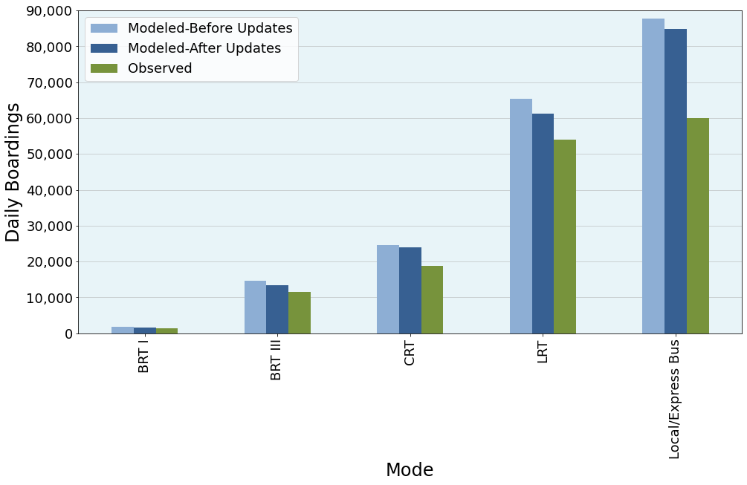

Figure 8. 2019 Daily Boardings by Mode – System-Wide

Using the updated transit input files brings the model a little closer to the observed data (27% down from 33%).

To correct for the overestimation of transit trips, the relative share by mode was calculated. By comparing the share of total boardings of each mode, the travel model is shown to more accurately reflect the distribution of transit trips amongst modes. When looking at the difference between the models and observed, the modeled boardings are within 4% for all modes both before and after updates. BRT and CRT are both within about a difference of about 1%. LRT and Local bus are the most off at 4% before to 5% after. Unlike the total boardings, the transit updates do not bring modeled shares closer to observed shares, except for CRT.

Table 4. 2019 Daily Boardings Share by Mode – System-Wide

| **Transit**  **Mode** | **Observed** | **Modeled-Before Updates** | | **Modeled-After Updates** | |
| --- | --- | --- | --- | --- | --- |
| **Daily Boardings Share** | **Daily Boardings Share** | **Difference** | **Daily Boardings Share** | **Difference** |
| **BRT I** | 1.0% | 0.9% | -0.1% | 0.9% | -0.2% |
| **BRT III** | 7.9% | 7.5% | -0.4% | 7.2% | -0.7% |
| **CRT** | 12.9% | 12.7% | -0.2% | 12.9% | 0.0% |
| **LRT** | 37.0% | 33.7% | -3.3% | 33.1% | -3.9% |
| **Local/Express Bus** | 41.1% | 45.2% | 4.1% | 45.9% | 4.8% |
| **Total** | 100.0% | 100.0% | 0.0% | 100.0% | 0.0% |

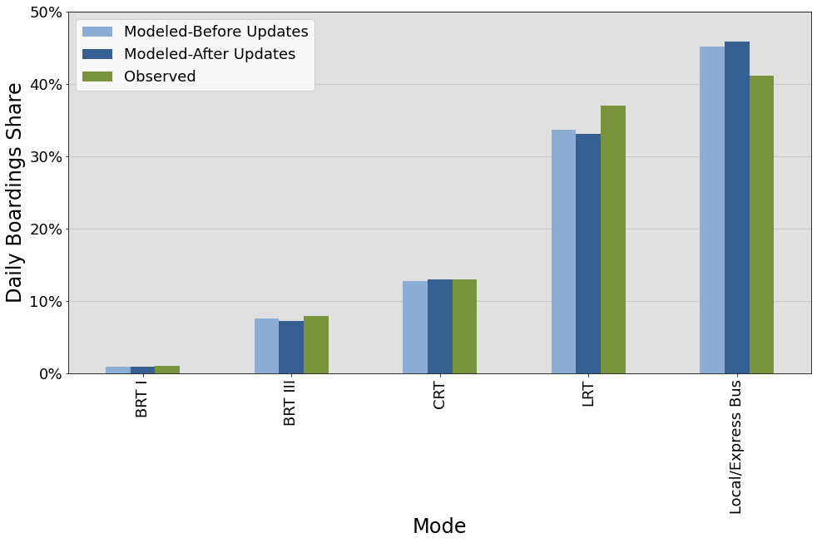

Figure 9. 2019 Daily Boardings Share by Mode – System-Wide

# 2019 Boardings by Service District and Route

A before/after comparison of the 2019 daily boardings and their shares by service district and route are shown in the following figures.

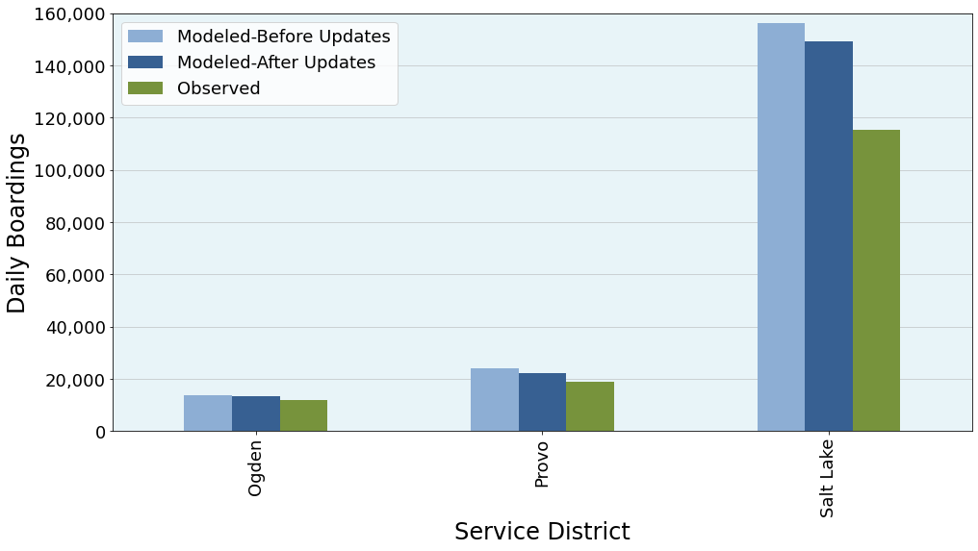

*Figure 10. Daily Boardings by Service District*

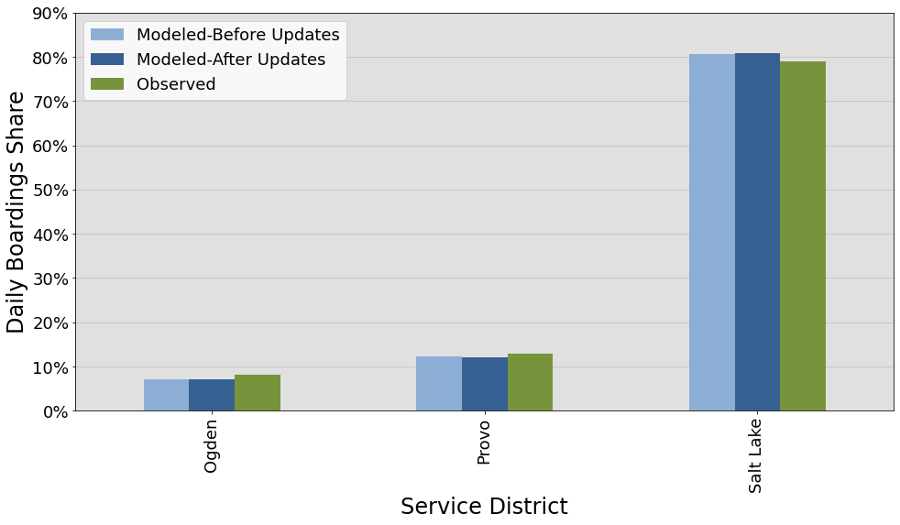

*Figure 11. Daily Boardings Share by Service District*

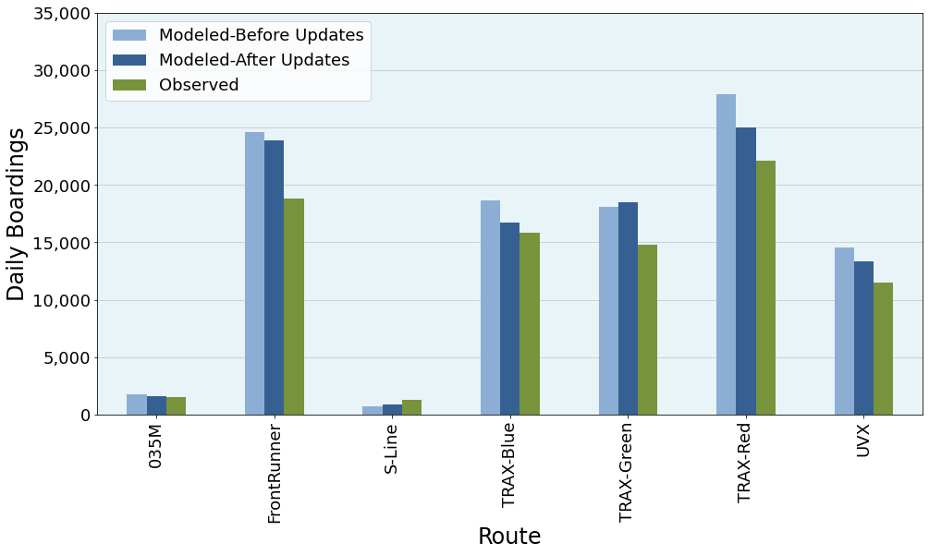

*Figure 12. Daily Boardings by Route – BRT/CRT/LRT*

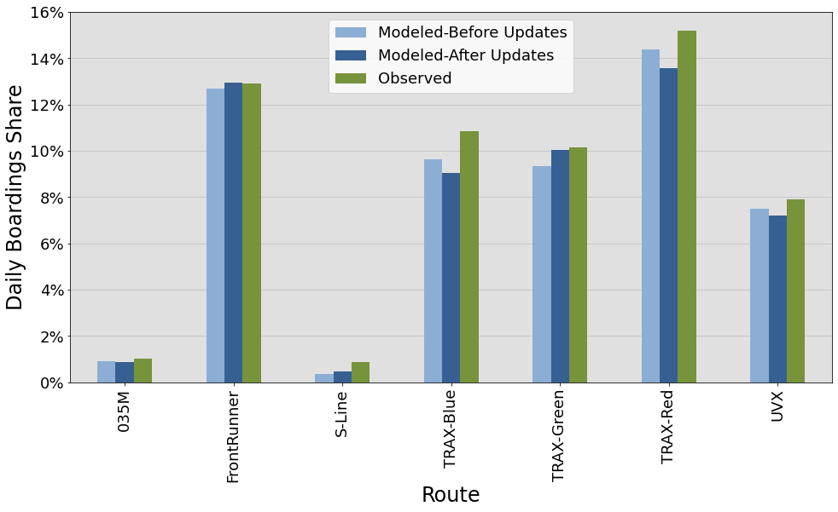

*Figure 13. Daily Boardings Share by Route – BRT/CRT/LRT*

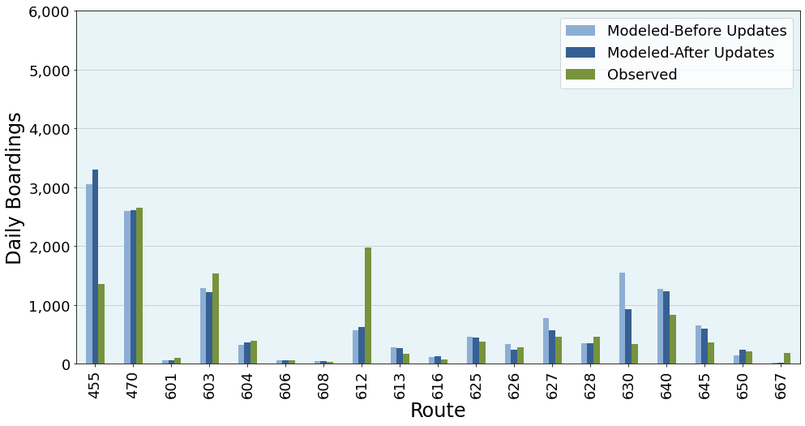

*Figure 14. Daily Boardings by Route – Local Bus – Ogden Service District*

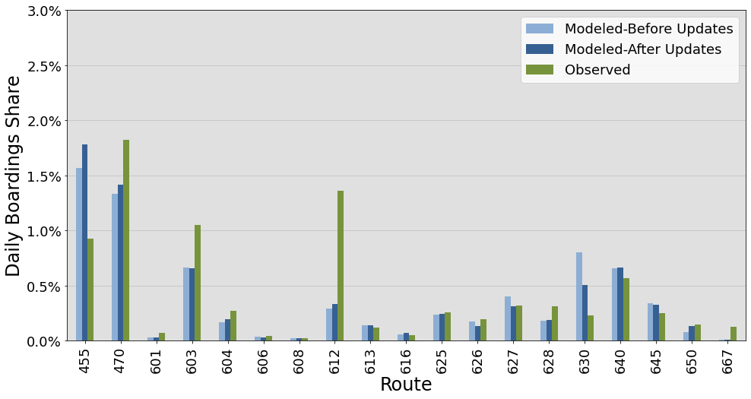

*Figure 15. Daily Boardings Share by Route – Local Bus – Ogden Service District*

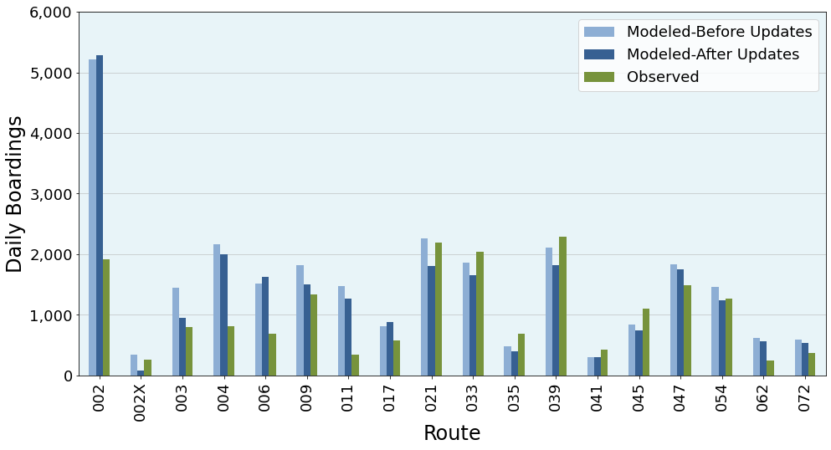

*Figure 16. Daily Boardings by Route – Local/Express Bus <200 – Salt Lake Service District*

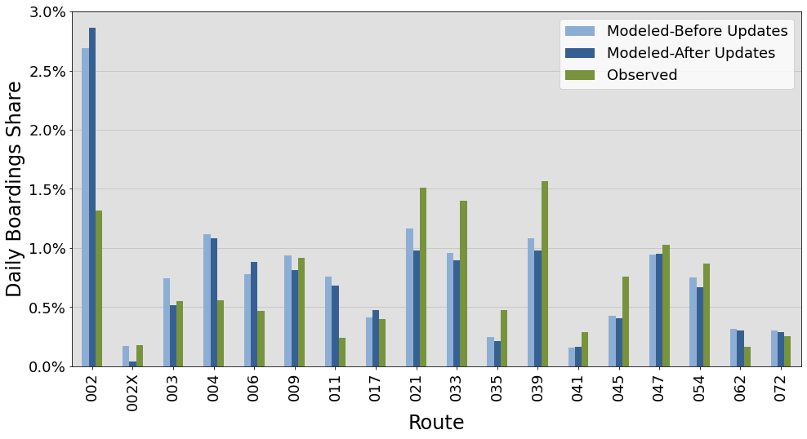

*Figure 17. Daily Boardings Share by Route – Local/Express Bus <200 – Salt Lake Service District*

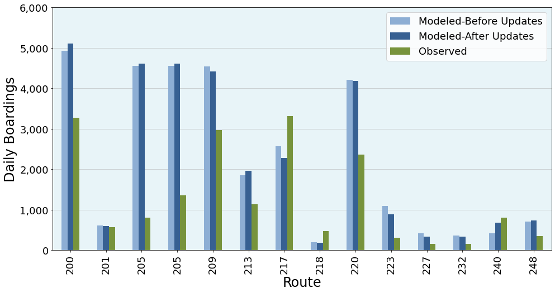

*Figure 18. Daily Boardings by Route – Local/Express Bus 200s – Salt Lake Service District*

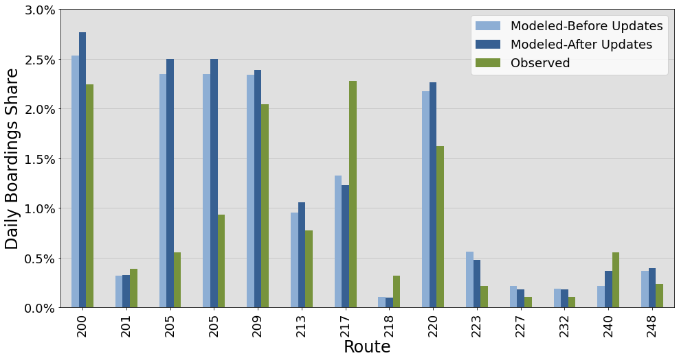

*Figure 19. Daily Boardings Share by Route – Local/Express Bus 200s – Salt Lake Service District*

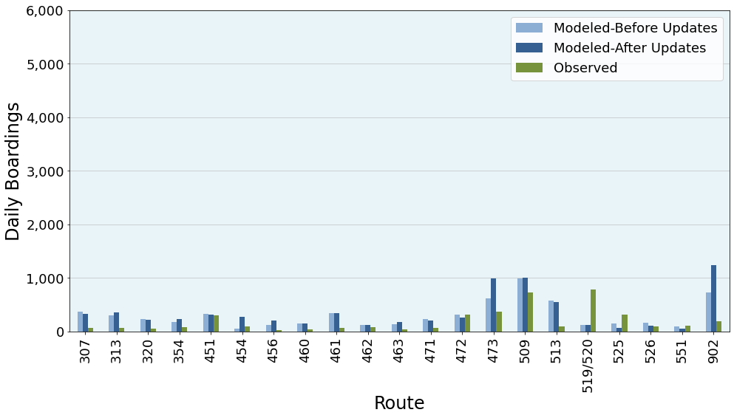

*Figure 20. Daily Boardings by Route – Local/Express Bus >200 – Salt Lake Service District*

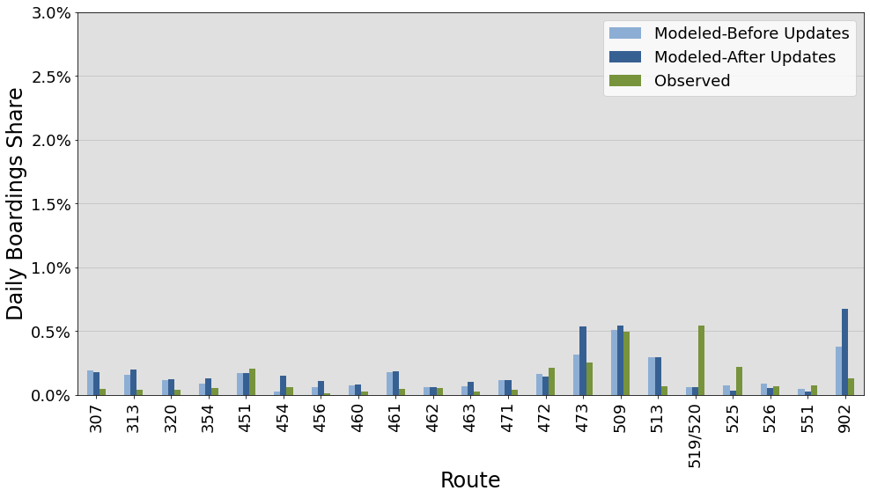

*Figure 21. Daily Boardings Share by Route – Local/Express Bus >200 – Salt Lake Service District*

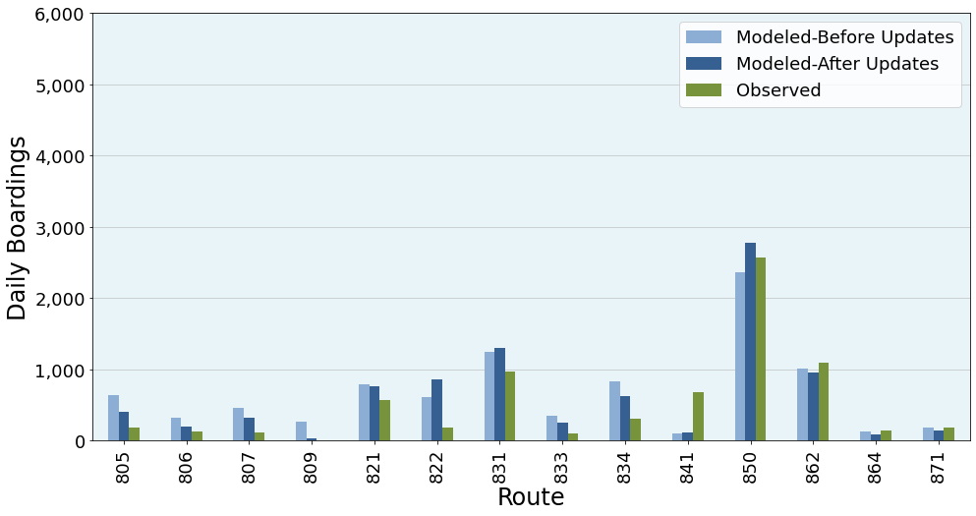

*Figure 22. Daily Boardings by Route – Local/Express Bus – Provo Service District*

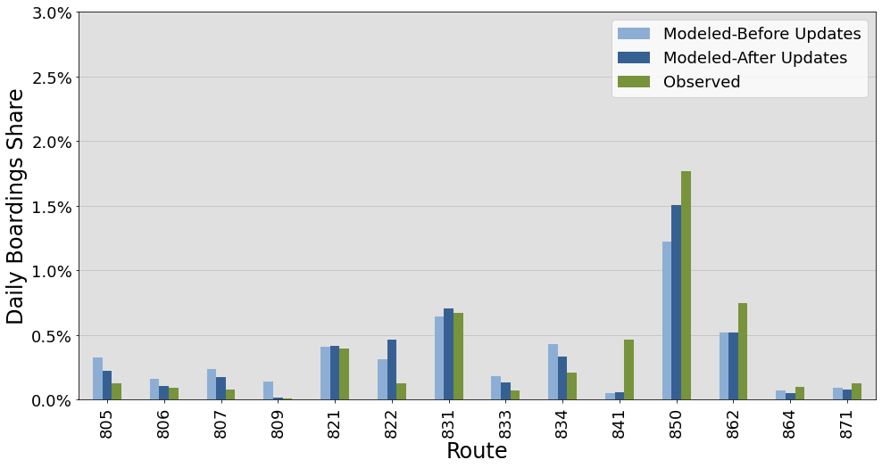

*Figure 23. Daily Boardings Share by Route – Local/Express Bus – Provo Service District*